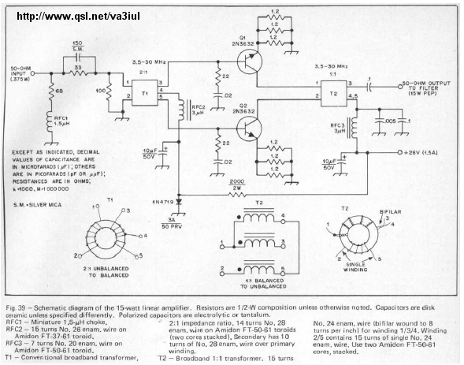

<https://yo4hhp.wordpress.com/2012/10/22/20w-hf-amplifier-with-rd16hhf1-k5bcq-ki/>

<https://www.youtube.com/watch?v=yEmUkqqU_vA>